**RICOH PRINTER - PARCHMENT PAPER PRINTING**

This guide is for my RICOH laser printer. Unlike the HP one we had at home, this one does not have a flat feeding tray (has a inclined vertical one) and from my tests it seems very finicky about accepting parchment paper.

If not inserted properly, the paper jams and sometimes even does not go in properly, or comes out crumpled and all.

**IMPORTANT THINGS TO ENSURE :**

1. Paste the **parchment paper on a regular A4 sheet with the convex side of parchment paper on the top (the image will be printed here) !**

2**. Attach the parchment paper approximately 15mm from the top edge** of the a4 sheet.

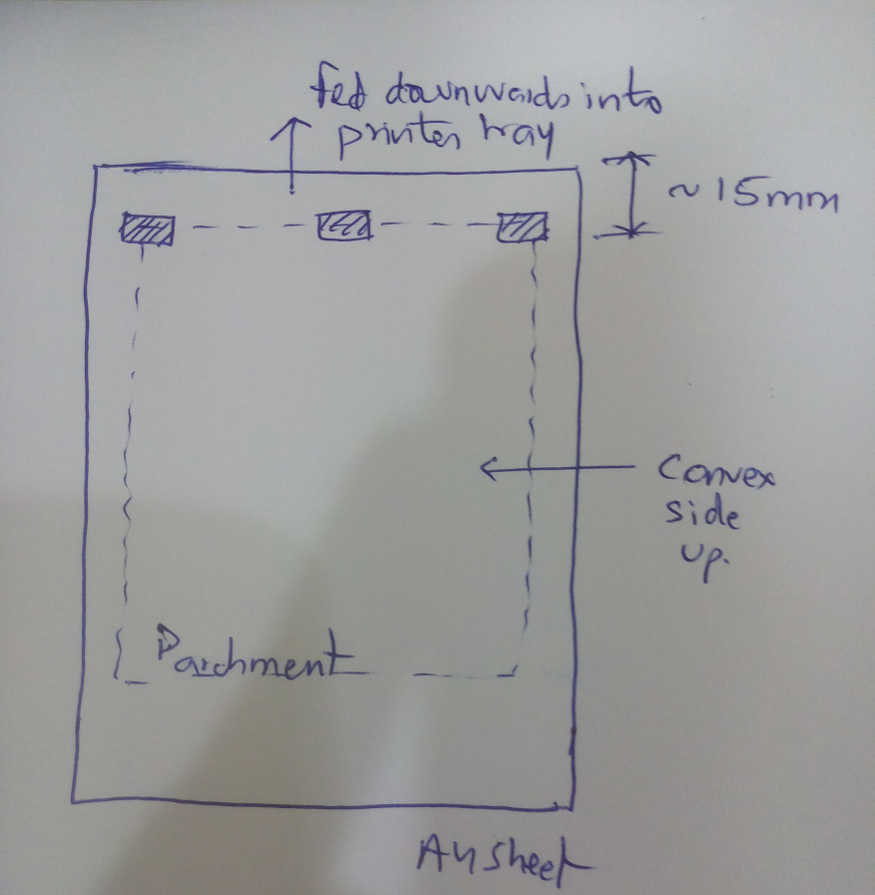

3. This **top edge of the sheet will be fed first into the printer. Draw a small arrow pointing upwards (towards the edge of the sheet).**

4. **Stick 3 small pieces of masking tape on the top side of parchment paper** (side where the arrow is drawn). this is the only tape required.

5. While feeding A4+parchment combo keep the feeding tray empty. Put in the paper, and hold the protruding end of the paper with both hands and feed it in gently as the printer pulls it in so that the parchment paper does not crumble.

6. **In the inkscape drawing keep the pcb drawings in the top side of the A4 canvas. The drawing should be atleast 85mm from the top of the canvas**.

**PRINTER SETTINGS :**

- Size : A4  
- Paper type : PLAIN  
- Leave rest of the settings on default!

